The VIU Consciousness Group represents an interdisciplinary group of Faculty and Staff interested in topics and approaches related to consciousness, holism, healing, and spirituality. Within the University we share resources, develop reading circles, lecture in each other’s classes, and promote interdisciplinary dialogue on curriculum-relevant topics such as contemplative pedagogy, perennial philosophy, evolution of consciousness, and different worldviews informing health and well-being of our global community.
The Group also integrates its work with the VIU Student Consciousness Club. In collaboration, we sponsor and facilitate events on and off campus for both the University and the broader communities. These include guest speakers, films, and workshops on topics such as holistic healing, Integral and Transpersonal Psychology, spirituality, Eastern and Indigenous knowledge, holistic pedagogy, and anomalous phenomena.
If you are interested in having your email added to the list to be updated on events, please contact:
Rachel Cooper Les Malbon
Department of Psychology Department of Sport, Health and Physical Education
rachel.cooper@viu.ca les.malbon@viu.ca

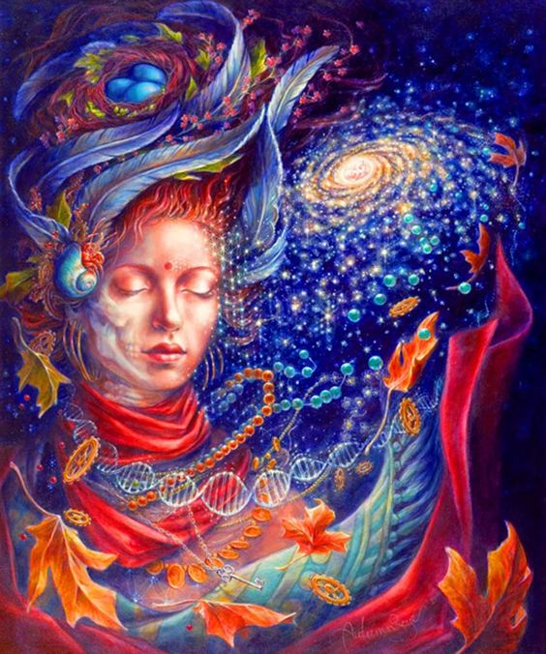
Artwork by Autumn Skye Morrison

